Policy No.: 8220
Effective Date: 10/24/2016
Last Revision: June 2024

Policy No.: 8230

Effective Date: 10/24/2016
Last Revision: January 2022

Policy Title:
Radiation Safety Program

Radiation Safety Program

Policy Title:
Radiation Safety Program

Policy Title:
Radiation Safety Program

Policy Title:
Radiation Safety Program

Radiation Safety Program

Policy Title:
Radiation Safety Program

Policy Title:
Radiation Safety Program

Policy Title:
Radiation Safety Program

Radiation Safety Program

Policy Title:
Radiation Safety Program

Policy Title:
Radiation Safety Program

Policy Title:
Radiation Safety Program

Radiation Safety Program

Policy Title:
Radiation Safety Program

Policy Title:
Radiation Safety Program

Policy Title:
Radiation Safety Program

Radiation Safety Program

Policy Title:
Radiation Safety Program

Policy Title:
Radiation Safety Program

Policy Title:
Radiation Safety Program

Radiation Safety Program

Policy Title:
Radiation Safety Program

Policy Title:
Radiation Safety Program

Policy Title:
Radiation Safety Program

Radiation Safety Program

Policy Title:
Radiation Safety Program

Policy Title:
Radiation Safety Program

Policy Title:
Radiation Safety Program

Radiation Safety Program

Policy Title:
Radiation Safety Program

Policy Title:
Radiation Safety Program

Responsible Office: Department of Public Safety
Responsible Official: Associate VP of Public Safety & Administrative Services

Contents
1.0 Introduction 3
2.0 Definitions 4
3.0 Roles and Responsibilities 5
4.0 General Equipment and Safety Requirements 6
5.0 Radiation Surveys 7
6.0 Personnel Monitoring 7
7.0 Training……………………………………………….………………………………………….8
Appendix A: Radiation Safety Officers 8
Appendix B: Radiation Dosimeter Badge 10
Appendix C: Dental Hygiene Radiation Safety Program……...………………………………….14

1.0 Introduction
This Environmental Health and Safety Policy sets forth the authority, limitations and responsibilities of the University of New Haven’s Radiation Safety Officers and other administrative personnel with regard to managing radiation exposure. Analytical x-ray equipment is used for x-ray diffraction analysis, fluorescence analysis, or direct x-ray transmission analysis of materials. These analytical x-ray systems are comprised of components that utilize x-rays to determine elemental composition, or to examine the microstructure of materials. These analytical x-ray devices are used for nonmedical purposes. Operational procedures will be established to ensure that radiation exposures as kept low as reasonably achievable (ALARA) with due considerations to the feasibility and nature of the research being conducted. This safety program establishes University procedures for the safe operation of analytical x-ray equipment and the associated potential radiation hazards. University Environmental Health and Safety personnel, may establish, alter, or terminate the Radiation Safety Program.

1.1 Policy Statement

Analytical x-ray equipment in the possession of the University is subject to registration with the State of Connecticut and other applicable state and federal regulations. University EHS must be notified of the possession of such equipment prior to utilization to ensure registration of the device and the completion of a safety survey and audit by the Radiation Safety Officer. Individuals in charge of the installation and all equipment operators shall be familiar with applicable operating procedures and regulations governing the x-ray installation and complete the University required training prior to equipment use.

1.2 Enforcement
Violations of this policy may result in appropriate disciplinary measures.

1.3 Reason for the Policy
Analytical x-ray equipment is used for scientific research at the University. Analytical x-ray equipment has become a major tool in research and quality control programs. Despite the advances in operating techniques and equipment design, the most common hazards are due to operator errors and equipment malfunctions. The potential exposure to the primary beam is of a major concern when evaluating potential radiation exposures. Exposures to the primary beam in a typical analytical x-ray unit may be as great as 100,000 R/min. This program applies to all departments, supervisors, employees, students, visiting scientists, and any personnel from other organizations whose work involves the use of analytical x-ray equipment at the University. Operational procedures will be established for each x-ray unit to maintain radiation exposures as low as reasonably achievable (ALARA) with due considerations as to the feasibility and nature of the research being conducted.

2.0 Definitions

Radiation Safety Officer. A designated person responsible for the safe use of radiation and radioactive materials as well as regulatory compliance.

Authorized User. An individual who has received specific training and is approved by University EHS personnel to work with or around x-ray equipment.

G.M. Survey Meter. A Geiger-Meuller (GM) survey meter is the most common device used for the detection of radioactive contamination.

Dosimeter Badge. A device used to measure an absorbed dose of ionizing radiation. (See Appendix B.)

ALARA (As Low As Reasonably Achievable). The University is committed to keeping exposures to radiation ALARA. This means that every reasonable effort shall be made to maintain radiation exposures as far below the dose limits as practical, taking into account the state of technology, the economics of the improvements in relation to the benefits, and other socioeconomic considerations.

Fail-Safe Characteristic. A design feature that causes beam port shutters to close upon failure of a safety or warning device.

Safety Device. A device which prevents entry of any portion of the individual’s body into the primary x-ray beam path or which causes the beam to be shut off upon entry into its path shall be provided on all open-beam configurations.

3.0 Roles and Responsibilities

University EHS and the University Radiation Safety Officer
- Provide training and instruction in the safety procedures and practices required for all persons who work with or near the x-ray machine.
- Maintain a current listing of all analytical x-ray equipment and its authorized users.
- Evaluate each installation as to the control of radiation exposures including recommendations for placement of radiation warning signs and/or warning devices.
- Perform routine annual radiation safety inspections of x-ray equipment.
- Review and approve modifications to the x-ray equipment that affects radiation protection including x-ray shielding, and safety interlocks.
- Provide personnel monitoring badges and area monitors as needed.
- Investigate any unusual radiation exposures to personnel and take remedial action if necessary
- Assist in achieving compliance with all applicable federal, state, and local rules and regulations.
- Register x-ray units with the Connecticut Department of Energy and Environmental Protection as per section 22a-148 to 22a-158 of the General Statutes.

Laboratory Managers
- Ensure that all personnel under their supervision are registered to receive general training in the safe use of analytical x-ray equipment.
- Ensure that only authorized users will enter the areas that are restricted due to the use of the analytical x-ray equipment.
- Provide specific hands-on training to the authorized users for each analytical x-ray unit.
- Ensure that the lab housing the x-ray machine has a properly operating radiation survey instrument.

Users’ Responsibilities
- Each authorized user of the analytical x-ray equipment is responsible for wearing the assigned personnel monitoring badge(s) as required.
- Perform area monitoring of the x-ray unit set-up when the beam is energized.
- Notify the Radiation Safety Officer when the x-ray machine needs servicing, or if any safety device, or interlock is not functional or has been tampered with.
- Notify the Radiation Safety Officer if it is known or suspected that a radiation exposure of personnel may have occurred.
- Notify the Radiation Safety Officer if the x-ray unit is moved.
- Notify the Radiation Safety Officer if there are changes in operating parameters such as kV and mA beyond that which were initially established.
- Notify the Radiation Safety Officer if there is any major service performed on the x-ray unit.

4.0 General Equipment and Safety Requirements

- The entrance(s) to any area that is restricted for radiation protection purposes will be posted with a sign bearing the radiation symbol and the words, “CAUTION RADIATION - THIS AREA CONTAINS EQUIPMENT WHICH PRODUCES X-RAYS WHEN ENERGIZED - TO BE OPERATED ONLY BY QUALIFIED PERSONNEL.”
- The x-ray unit switch that energizes the x-ray tube should be posted with a sign bearing the radiation symbol and the words, “CAUTION RADIATION – THIS EQUIPMENT PRODUCES RADIATION WHEN ENERGIZED - TO BE OPERATED ONLY BY QUALIFIED PERSONNEL.”
- Each x-ray unit shall have a fail-safe warning light to indicate when the x-ray tube is energized. The light will be energized by the same switch that turns the beam on. The light shall either function as a fuse, or the light will be equipped with a twin-bulb redundancy.
- The analytical x-ray equipment should be placed in a separate room from other work areas whenever practical.
- All safety devices such as interlocks, shutters, warning lights, etc. will be tested weekly or upon each use (if use is less frequent) to ensure proper operation.
- Safety interlocks will not be routinely used to deactivate the x-ray beam.
- Each x-ray housing will be constructed such that the leakage radiation measured at 5 cm from its surface does not exceed 2.5 mR/hr at any power rating.
- The analytical x-ray equipment user should be in immediate attendance at all times when the equipment is in operation.
- When not in operation, the equipment will be secured in such a way as to be accessible to or operable by analytical x-ray equipment users only (i.e. lock-out device).

5.0 Radiation Surveys

Analytical x-ray equipment USERS are required to make the following surveys with a G.M. survey meter:
  - A radiation survey will be performed prior to each new use of the x-ray equipment.
  - Weekly surveys should be performed to ensure radiation levels have not changed.
  - Periodic surveys should be performed on the local components to check for leakage radiation when the set-up is changed.
University EHS and/or the RSO will make surveys according to the following guidelines:
  - Upon the installation of the x-ray equipment and at least once a year thereafter.
  - Upon any change in the initial arrangement, number, or type of local components in the system.
  - Upon any maintenance requiring the disassembly or removal of a local component in the system.

6.0 Personnel Monitoring

  - The analytical x-ray equipment users will wear whole body badges. The monitoring device should be worn such that the body part nearest the primary beam is monitored.
  - Monitoring badges worn on the chest or abdomen may provide an indication as to the amount of stray radiation to the whole body.

7.0 Training

Forensics/Chemistry

- All students must take the radiation safety training on Canvas each semester where course activities require it.
- All faculty must take the radiation safety training on Canvas each academic year where course activities require it.

Appendix A: Radiation Safety Officers
Forensic Science Department

Primary Radiation Safety Officer:
Dr. Brooke Kammrath
Title: Associate Professor
Department: Forensic Science Department
Email Address: BKammrath@newhaven.edu
Office Phone: Phone: 203-931-2989
Office: Dodds Hall, 404B

Secondary Radiation Safety Officer
Belén Lemieux

Title: Laboratory Manager
Department: Forensic Science Department
Email Address: BLemieux@newhaven.edu
Office Phone: 203-479-4587
Office: Dodds Hall, 402

Chemistry & Chemical Engineering Department

Primary Radiation Safety Officer
Dinos Dimas
Title: Associate Professor
Department: Chemistry & Chemical Engineering Department
Email Address: DDimas@newhaven.edu
Office Phone: 203-932-7154
Office: Buckman Hall, 329A

Secondary Radiation Safety Officer
Michele Berman
Title: Laboratory Supervisor
Department: Chemistry & Chemical Engineering Department
Email Address: MBerman@newhaven.edu
Office Phone: 208-479-4849
Office: Buckman Hall, 311

Dental Hygiene Department

Primary Radiation Safety Officer:
N/A
Title:
Department:
Email Address:
Office Phone: Phone:
Office:

Secondary Radiation Safety Officer
Kaylin Stratton
Title: Laboratory Manager
Department: Dental Hygiene Department
Email Address: KStratton@newhaven.edu
Office Phone: 203-479-4711
Office: Dental Hygiene Building, 109

Appendix B: Radiation Dosimeter Badge

Purpose
This section is intended to provide additional information for those people who have been issued or are interested in being issued radiation monitoring badges.
How the Dosimeter Badges Work

The Luxel body badge contains a sheet of radiation-sensitive aluminum oxide sealed in a light and moisture proof packet. When atoms in the aluminum oxide sheet are exposed to radiation, electrons are trapped in an excited state until irradiated with a specific wavelength of laser light. The released energy of excitation, which is given off as visible light, is measured to determine radiation dose.
The packet contains a series of filters designed so that the energy and type of radiation can be determined. In order for the radiation type and energy to be determined, the dosimeter must be worn so that the front of the dosimeter faces towards the source of radiation.
Luxel body dosimeters are among the most sensitive dosimeters available. The minimum detectable does is 1 millirem for x-rays and gamma rays and 10 millirem for energetic beta radiation.
Wearing Dosimeter Badges

If you are issued a Luxel body badge, you will receive a gray plastic badge holder and a badge packet sealed inside a cellophane-type plastic bag. Remove the badge from the bag and snap it into the gray holder.
Wear your body badge on the part of the body between your neck and waist most likely to be exposed to the greatest amount of radiation. Wear it so that the name tag faces toward the source of radiation.
Guidelines for Use

- Never share your badges or wear another person’s badges. Each badge is intended to be worn by only the designated person.
- Do not intentionally expose your badges to radiation. Intentional tampering with badges is a very serious matter.
- If you discover that your badges are contaminated, notify the RSO promptly and request replacement badges.
- No matter how curious you are, do not wear your badges when you receive a medical x-ray or other medical radiation treatment. Your badges are intended to document occupational dose, not medical dose.
Storage

Store your badges in a safe place, at work rather than at home. Be sure to store badges away from sources of radiation. Be careful to consider all sources of radiation. For example, if you store your badge clipped to your lab coat, make sure that your lab coat (or any other lab coat near it) is not contaminated.
Store your badges away from sources of heat (some badges such as TDLs show some sensitivity to environmental factors like heat). For example, badges left in cars over hot summer weekends may give false exposure readings.
Lost or Damaged Badges

If you lose, damage, or contaminate your badge, call the RSO immediately for a replacement. The RSO can generally provide you with a replacement badge within 24 hours of your request. Do not borrow anyone else’s badge.
Badge Exchange Processing

Badges are exchanged quarterly (except for Declared Pregnant Workers whose badges are exchanged monthly). You should expect to receive your new badges a day or two before the start of each calendar quarter. Snap the old Luxel body badge out of the gray holder and return just the badge itself. Keep the gray holder so that you can snap the new badge into it. Make sure that your old badges are available for collection on the first working day of each quarter. Ask your lab manager or your department’s RSO about how to return your badges.
Wearing a monitoring badge is a serious matter, as it can reflect on your lifetime recorded dose. Therefore, it is important for the RSO to be able to account for any missing or damaged badges. If your badges are not turned in on time or are lost, the RSO is required to conduct an investigation to estimate your dose and will ask you to provide an accounting of your activities involving radioactive sources during the period in which the badges should have been worn.
Emergency Processing

If you believe that you may have received an unusual dose (if you may have placed your hand in an x-ray beam, for example), notify the RSO immediately. Your badges will be returned for rapid emergency processing.
Dose Reports and How to Read Them

After you return your monitoring badges, the badges are sent out to the badge service company for processing. The RSO receives the dose reports several weeks after the monitoring period and reviews the dose reports. The RSO has established investigational levels at doses that are 10% or less of the federal and state dose limits. If a dose is reported that exceeds the investigational level, the RSO will contact you to determine whether the reported dose is likely to be accurate and to investigate the causes of the dose in an effort to minimize dose in the future.
After the RSO finishes its review, a copy of the dose report is forwarded to each Authorized User. Since the dose reports contain names, birthdates, etc. we do not recommend that the reports be posted in the lab. Contact your lab manager or department RSO to find out how the information from the monitoring reports is made available. A summary of your badge results can also be obtained by contacting the RSO.
For body badges, doses are reported as deep or shallow or as doses to the lens of the eye. Deep dose is due to penetrating radiation such as x- or gamma radiation. Deep doses are applied against the whole-body dose limit. Shallow dose is due to less penetrating radiation such as beta radiation and low energy x-rays. Shallow doses are applied against the skin dose limit. Dose to the lens of the eyes is due to an intermediate range of radiation and energies and is applied against the lens of the eye dose limit.
Doses are reported in millirem. The minimum reportable dose for body badges is 1 millirem for x-rays and gamma rays or 10 millirem for energetic beta radiation. If a dose of “M” is reported, the total dose received was minimal, i.e., less than the minimum reportable dose.
Contact the RSO if you change your name, if your name is misspelled, or if any other information in the dose report is incorrect.
Exposure History

Contact the RSO for a copy of your radiation exposure history. The RSO maintains radiation exposure records indefinitely.
If you terminate your employment with the University, your radiation exposure history will be provided to you or your new employer upon request. A signed release statement must accompany any request from your new employer.
Monitoring Badge Use at Other Institutions

Do not take University of New Haven issued badges to any other institution. University of New Haven badges are intended solely to measure the radiation dose you receive while working at the University of New Haven. If you perform radiation work at another institution, it is the responsibility of that institution to provide you with monitoring badges.
However, the University of New Haven must still control the dose you receive while working at the University of New Haven so that your total occupational dose does not exceed the state and federal dose limits. If you are issued radiation monitoring badges at any other institution, notify the RSO immediately. The RSO will contact that institution and request copies of your dose records.

* * *
This Policy’s Contact Person:
Associate VP of Public Safety & Administrative Services University of New Haven
300 Boston Post Road
West Haven, CT 06516
(O – 203-932-7147)

Appendix C: Dental Hygiene Radiation Safety Program

Dosimeter Badges

Dosimeters badges are posted outside of all rooms that contain radiation emitting devices. The Radiation Safety Officer overseeing Dental Hygiene is responsible for sending in dosimeter badges to be assessed quarterly by a third-party vendor. Reports can be accessed through an online account associated with the vendor, and are uploaded to a shared folder with EH&S.

Personal dosimetry badges are available for pregnant personnel upon request. Dosimeter badges (area monitors) will only be moved by the Radiation Safety Officer or the EH&S Department.

Training

All students, faculty, and staff who operate radiation-producing equipment must complete required radiation safety training prior to utilizing equipment. Students are presented the radiation safety training during class lectures and must complete and pass the mandatory Dental Radiation Quiz located on Canvas to receive credit. The course and associated quiz must be completed at the start of each semester if the student is utilizing radiation-emitting devices.

Staff and faculty are required to complete the online radiation safety course and quiz on Canvas once each academic year. Staff and faculty who operate radiation-emitting devices must complete the required training and quiz annually, regardless of certification, years of service, title, etc.

Best Practices

Shielding

Lead aprons are worn by patients during x-ray procedures to shield the body from unnecessary radiation exposure. Thyroid collars offer additional protection for the thyroid gland. If lead aprons become torn or damaged, they shall be replaced. Triumvirate Environmental and/or Environmental, Health, and Safety must be contacted to ensure proper disposal. Lead aprons are not permitted to be disposed of in the regular trash.

All dental x-ray rooms have walls and doors lined with lead to prevent exposure to personnel outside of the room operating radiation-emitting equipment.

Distance

The dental radiographer must avoid the primary beam and be at a minimum of six feet away from the source. The radiographer should be positioned perpendicular to the source (90 to 135 degrees from the beam). If it is not feasible to be at least six feet away from the beam, then a barrier must be utilized (i.e. door, wall). The operator shall remain in the shielded area during exposure.

Time

Dental radiographers should minimize time duration working with x-ray sources.

Safety Devices

Radiation-emitting devices within dental hygiene have a “dead man switch.” X-rays are only generated when authorized personnel are actively pressing the switch. Switches are located on the exterior wall of designated x-ray rooms.

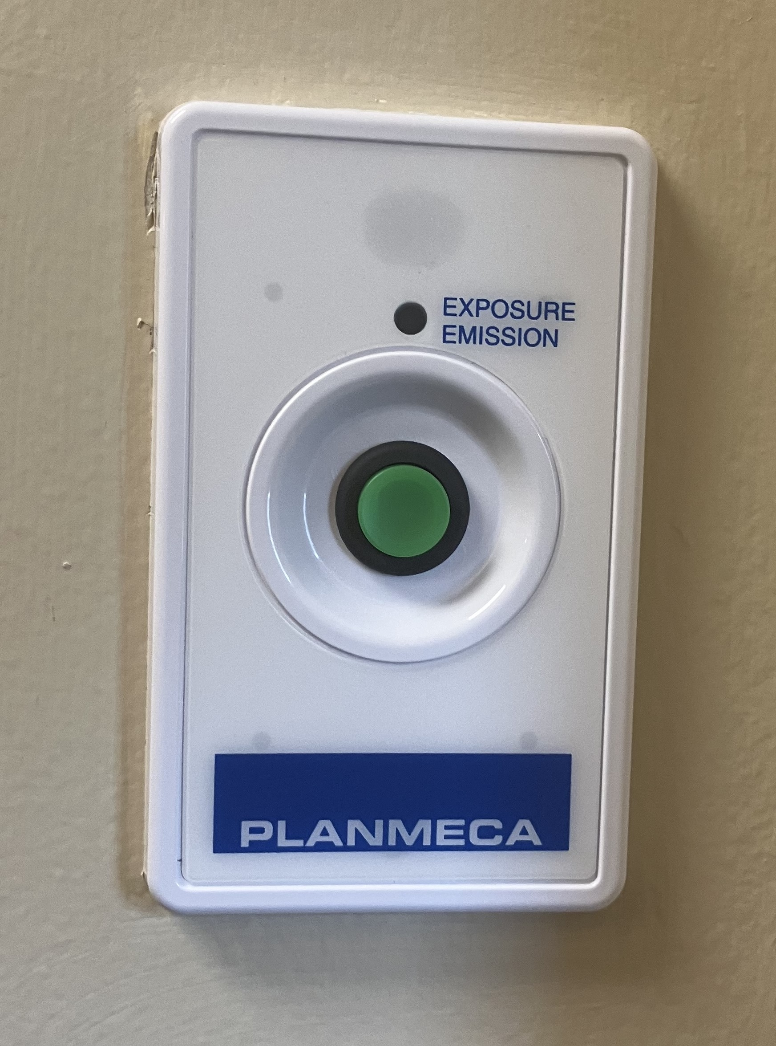

The following signage shall be posted and visible on the exterior door of all areas that contain x-ray equipment.
