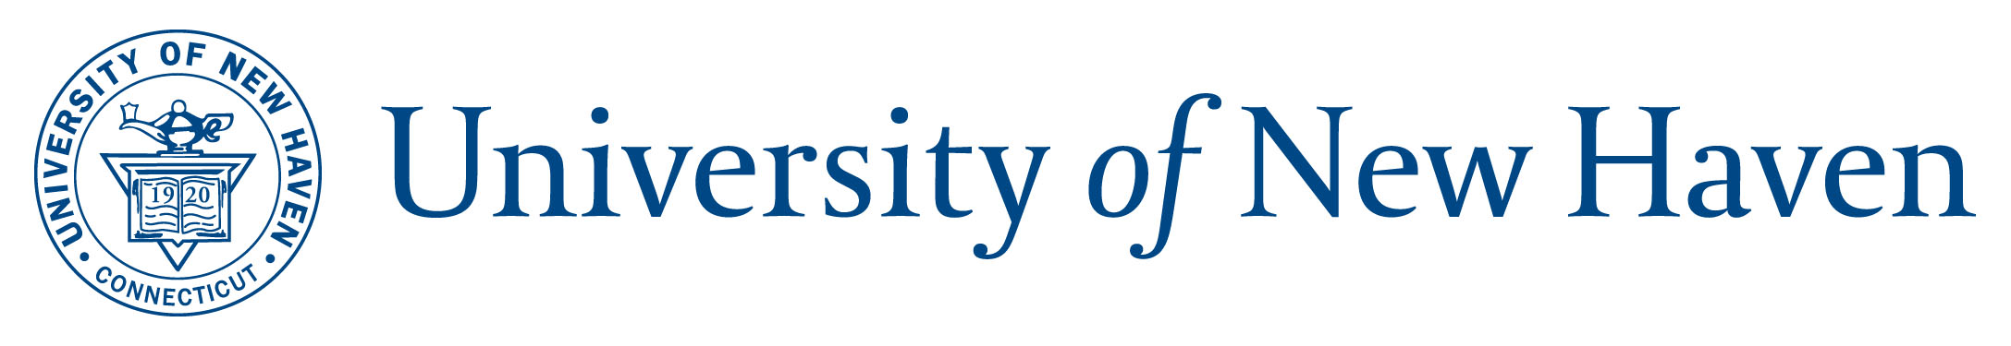Vacation Correction Request Form

Please complete this form to request a vacation correction to your record. Before completing this form, please first:

- discuss the reason for the adjustment with your supervisor,
- ensure your supervisor has approved or rejected all leave requests to ensure accurate balances.
This form must be forwarded to your supervisor for approval or denial. If the request is approved, the supervisor/manager should forward via email to HR for processing officeofhumanresources@newhaven.edu.

Please allow at least one pay period for any approved adjustment to be documented in your record.

- EMPLOYEE DETAILS:
Name: | Position Title:
Department:

Supervisor/Manager:
Reason/Justification for Request:

Signature:

I acknowledge that my signature below on this request attests to having provided factual and accurate information. I further acknowledge that if I have misrepresented the information in this request in any way, I may be subject to appropriate disciplinary action for falsification of records.

 | Approve | Deny | Comments
SUPERVISOR/MANAGER NAME:

SUPERVISOR/MANAGER SIGNATURE (will not be accepted without this approval)

